**Aim:** Implementation of Dimension and Fact tables and perform OLAP operations.

**Objective:** OLAP stands for Online Analytical Processing. The objective of OLAP is to analyze information from multiple database systems at the same time. It is based on multidimensional data model and allows the user to query on multi-dimensional data.

**Theory:**

* Online Analytical Processing Server (OLAP) is based on the multidimensional data model.
* The main aim of OLAP is to provide multidimensional analysis to the underlying data.

Following is the list of OLAP operations:

1. Roll-up
2. Drill-down
3. Slice
4. Dice
5. Pivot (rotate)

**Roll-up:**

* The roll-up operation (also called the drill-up operation) performs aggregation on a data cube, either by climbing up a concept hierarchy for a dimension or by dimension reduction.
* Figure 2.1 shows the result of a roll-up operation performed on the central cube by climbing up the concept hierarchy for location.
* This hierarchy was defined as the total order “street < city < province or state < country.”
* The roll-up operation aggregates the data by ascending the location hierarchy from the level of city to the level of country.
* In other words, rather than grouping the data by city, the resulting cube groups the data by country.

**Drill-down:**

* Drill-down is the reverse of roll-up. It navigates from less detailed data to more detailed data.
* Drill-down can be realized by either stepping down a concept hierarchy for a dimension or introducing additional dimensions.
* Figure 2.1 shows the result of a drill-down operation performed on the central cube by stepping down a concept hierarchy for time defined as “day < month < quarter < year.”
* Drill-down occurs by descending the time hierarchy from the level of quarter to the more detailed level of month.
* The resulting data cube details the total sales per month rather than summarizing them by quarter.

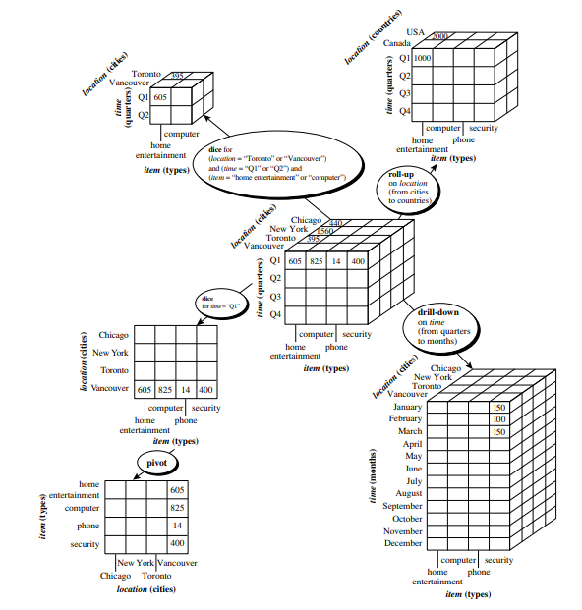

**Figure 2.1: Examples of typical OLAP operations on multidimensional data.**

**Slice:**

* The slice operation performs a selection on one dimension of the given cube, resulting in a subcube.
* Figure 2.1 below shows a slice operation where the sales data are selected from the central cube for the dimension time using the criterion time = “Q1.”

**Dice:**

* The dice operation defines a subcube by performing a selection on two or more dimensions.
* Figure 2.1 shows a dice operation on the central cube based on the following selection criteria that involve three dimensions: (location = “Toronto” or “Vancouver”) and (time = “Q1” or “Q2”) and (item = “home entertainment” or “computer”).

**Pivot:**

* Pivot (also called rotate) is a visualization operation that rotates the data axes in view to provide an alternative data presentation.
* Figure 2.1 shows a pivot operation where the item and location axes in a 2-D slice are rotated.

**Problem Statement:**

The problem is to design and implement a data warehousing solution for a bookstore that optimally organizes and manages its vast data, including sales, inventory, customer information, and more, to facilitate efficient reporting and analytics. This involves creating both a star schema and a snowflake schema to support various business intelligence and decision-making processes, while ensuring data accuracy, integrity, and performance

**Code:**

**Create Database “book”:**

Create database book;

**Create Dimension Tables:**

CREATE TABLE Book (

Book_Id INT PRIMARY KEY,

Book_Name VARCHAR(100),

Book_Genre VARCHAR(50),

Book_Author VARCHAR(100),

Book_Cost INT

);

CREATE TABLE Store (

Store_Id INT PRIMARY KEY,

Store_Name VARCHAR(100),

Store_Address VARCHAR(200),

Store_Pincode INT,

Store_City VARCHAR(100)

);

CREATE TABLE Supplier (

Supplier_Id INT PRIMARY KEY,

Supplier_Name VARCHAR(100),

Supplier_Address VARCHAR(200)

);

CREATE TABLE Users (

User_Id INT PRIMARY KEY,

User_Name VARCHAR(100),

User_Address VARCHAR(200),

User_Pincode INT,

User_City VARCHAR(100)

);

CREATE TABLE Orders (

Order_Id INT PRIMARY KEY,

Order_Cost INT,

Order_Quantity INT

);

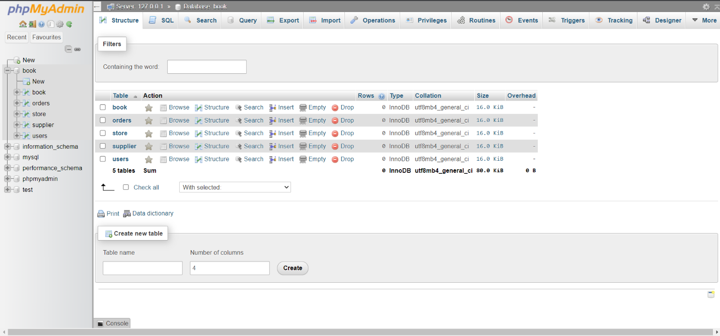

**Create Fact Table:**

CREATE TABLE Fact_Sales (

Book_Id INT,

Store_Id INT,

User_Id INT,

Supplier_Id INT,

Order_Id INT,

Total_Sales INT,

Total_Cost INT,

PRIMARY KEY (Book_Id, Store_Id, Order_Id),

FOREIGN KEY (Book_Id) REFERENCES Book(Book_Id),

FOREIGN KEY (Store_Id) REFERENCES Store(Store_Id),

FOREIGN KEY (User_Id) REFERENCES Users(User_Id),

FOREIGN KEY (Supplier_Id) REFERENCES Supplier(Supplier_Id),

FOREIGN KEY (Order_Id) REFERENCES Orders(Order_Id)

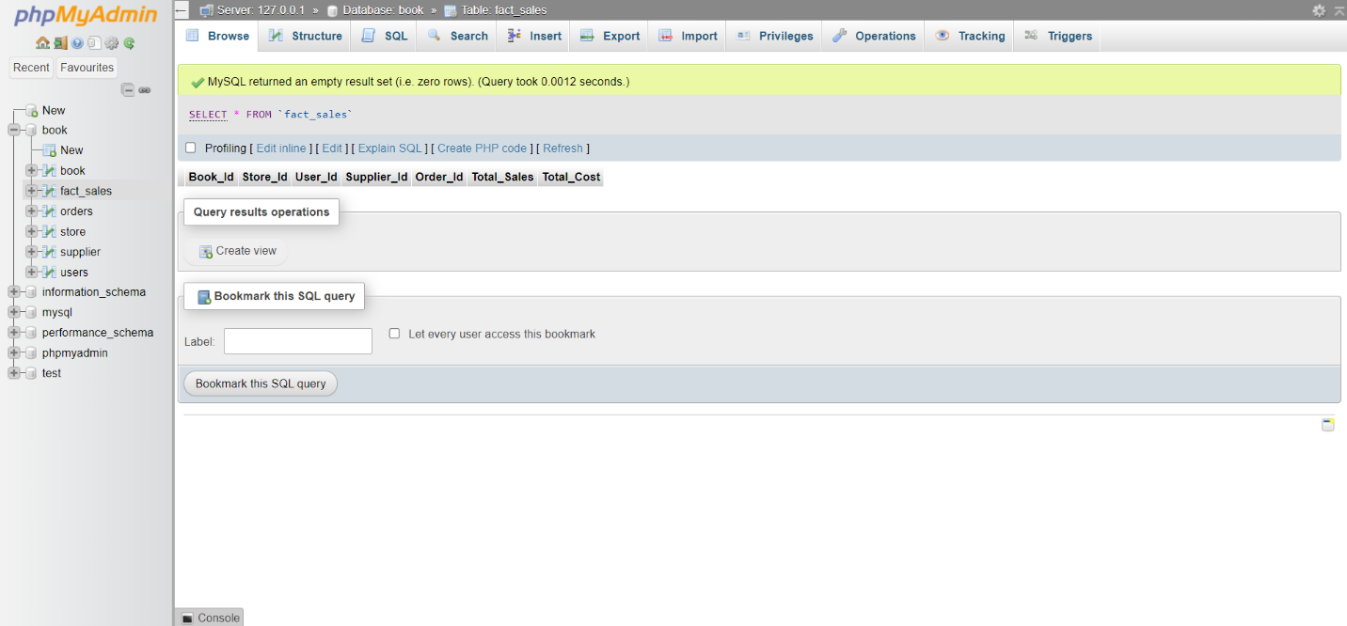 );

**Inserting values in both dimension and fact tables:**

INSERT INTO Book VALUES

(1, 'To Kill a Mockingbird', 'Fiction', 'Harper Lee', 250),

(2, '1984', 'Fiction', 'George Orwell', 200),

(3, 'The Great Gatsby', 'Fiction', 'F. Scott Fitzgerald', 180);

INSERT INTO Store VALUES

(1, 'A Store', '123 Main St', 12345, 'New York'),

(2, 'B Store', '456 Oak Rd', 67890, 'Chicago'),

(3, 'C Store', '789 Elm St', 23456, 'Los Angeles');

INSERT INTO Supplier VALUES

(1, 'ABC Supplier', '111 Industry Ave'),

(2, 'XYZ Supplier', '222 Commerce St'),

(3, '123 Supplier', '333 Trade Blvd');

INSERT INTO Users VALUES

(1, 'John Doe', '100 1st St', 12345, 'New York'),

(2, 'Jane Smith', '200 2nd St', 23456, 'Los Angeles'),

(3, 'Bob Johnson', '300 3rd St', 34567, 'Chicago');

INSERT INTO Orders VALUES

(1, 500, 10),

(2, 400, 8),

(3, 600, 12);

INSERT INTO Fact_Sales VALUES

(1, 1, 1, 1, 1, 5000, 2500),

(2, 2, 2, 2, 2, 4000, 1600),

(3, 3, 3, 3, 3, 7200, 2160);

**Displaying the tables:**

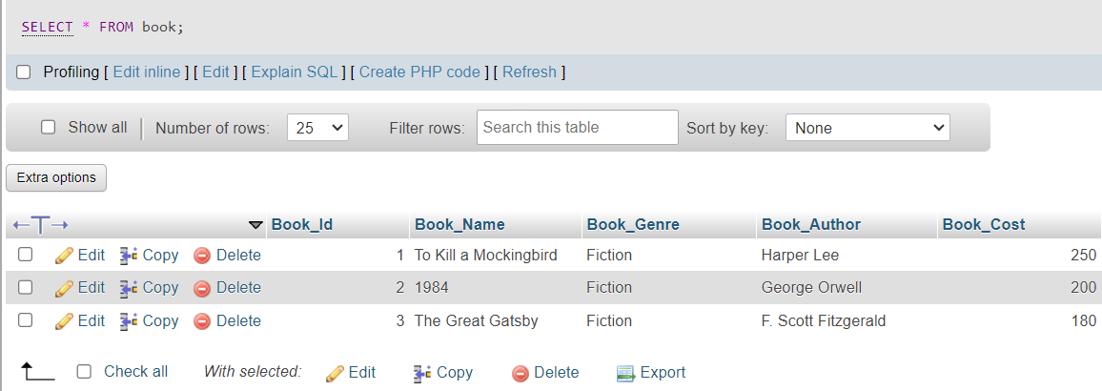SELECT * FROM book;

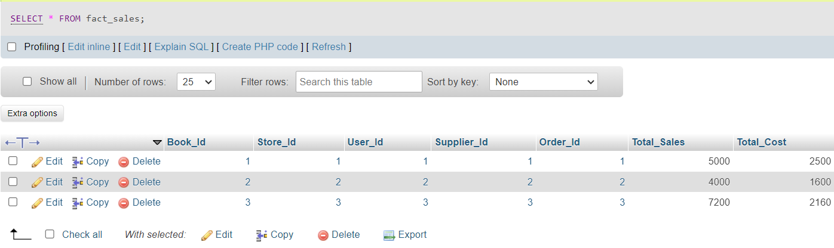SELECT * FROM fact_sales;

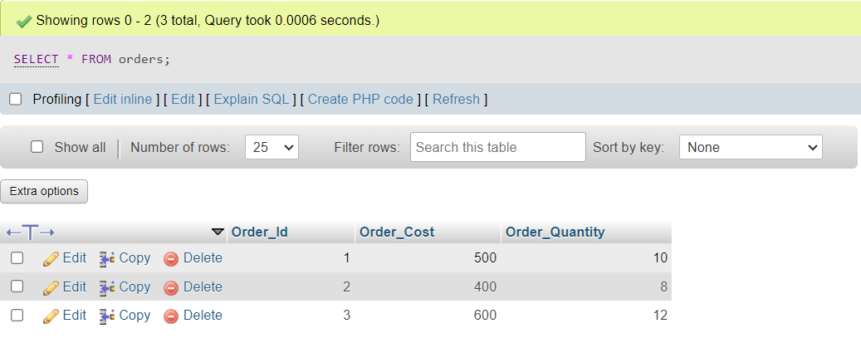SELECT * FROM orders;

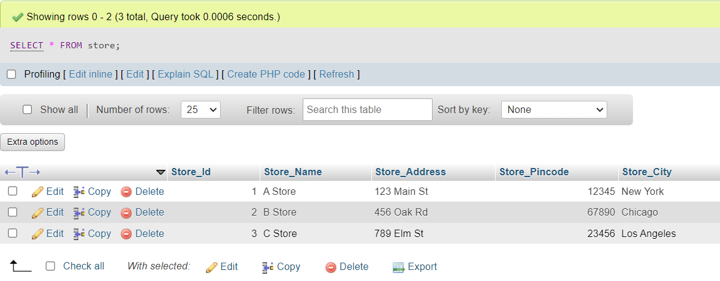SELECT * FROM store;

SELECT * FROM supplier;

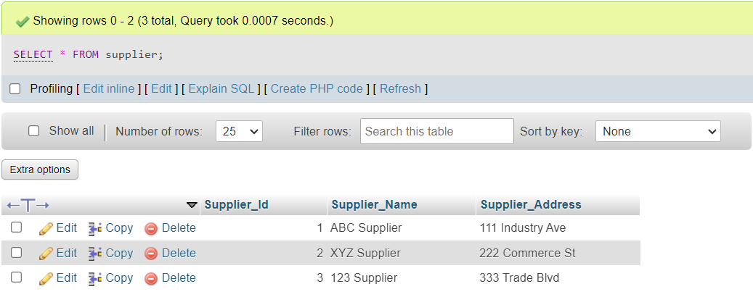

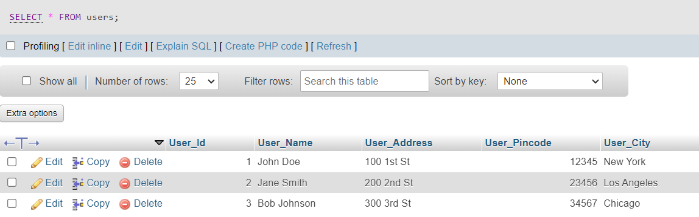SELECT * FROM users;

**Write SQL Queries for all the above OLAP operations:**

**Rollup:**

SELECT Book_Id, SUM(Total_Sales) AS Total_Sales, SUM(Total_Cost) AS Total_Cost

FROM Fact_Sales

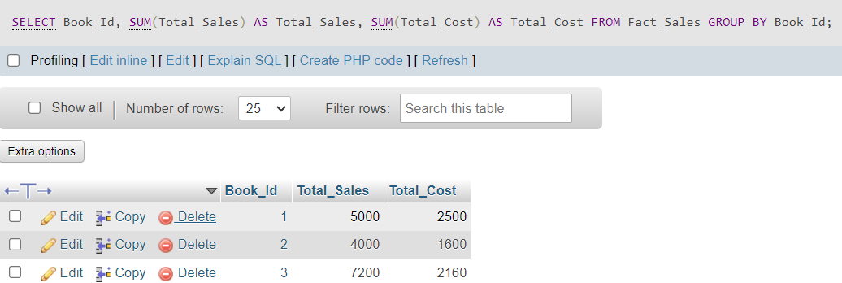GROUP BY Book_Id;

**Drill Down:**

SELECT Book_Id, Store_Id, SUM(Total_Sales) AS Total_Sales, SUM(Total_Cost) AS Total_Cost

FROM Fact_Sales

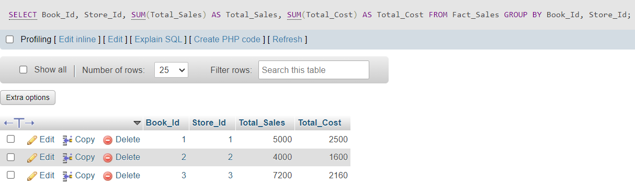GROUP BY Book_Id, Store_Id;

**Slice:**

SELECT Book_Id, SUM(Total_Sales) AS Total_Sales, SUM(Total_Cost) AS Total_Cost

FROM Fact_Sales f

JOIN User u ON f.User_Id = u.User_Id

WHERE u.User_City IN ('New York', 'Los Angeles')

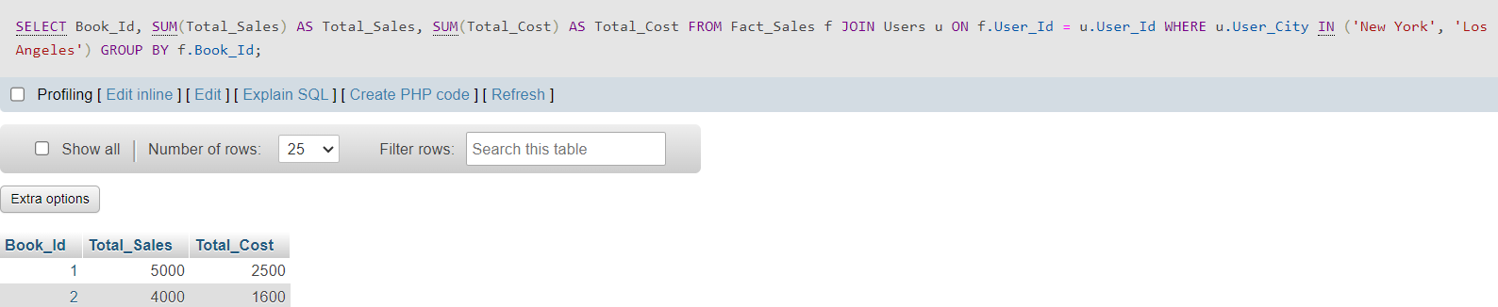GROUP BY f.Book_Id;

**Dice:**

SELECT Store_Id, Supplier_Id, SUM(Total_Sales) AS Total_Sales, SUM(Total_Cost) AS Total_Cost

FROM Fact_Sales

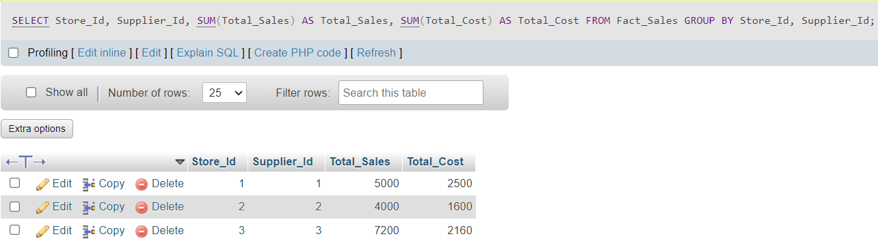GROUP BY Store_Id, Supplier_Id;

**Pivot:**

SELECT

User_City,

SUM(CASE WHEN Book_Id = 1 THEN Total_Sales END) AS Book_1_Sales,

SUM(CASE WHEN Book_Id = 1 THEN Total_Cost END) AS Book_1_Cost,

SUM(CASE WHEN Book_Id = 2 THEN Total_Sales END) AS Book_2_Sales,

SUM(CASE WHEN Book_Id = 2 THEN Total_Cost END) AS Book_2_Cost,

SUM(CASE WHEN Book_Id = 3 THEN Total_Sales END) AS Book_3_Sales,

SUM(CASE WHEN Book_Id = 3 THEN Total_Cost END) AS Book_3_Cost

FROM Fact_Sales f

JOIN User u ON f.User_Id = u.User_Id

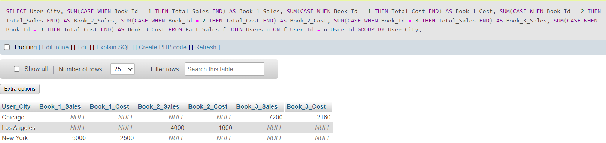GROUP BY User_City;

**Conclusion:**

Thus, we have learned implementation of Dimension and Fact tables and perform OLAP operations on database. OLAP stands for Online Analytical Processing. The objective of OLAP is to analyze information from multiple database systems at the same time.